CANON TUOMAS MÄKIPÄÄ
Candidate for the General Synod

A Church that belongs to everyone and is governed well
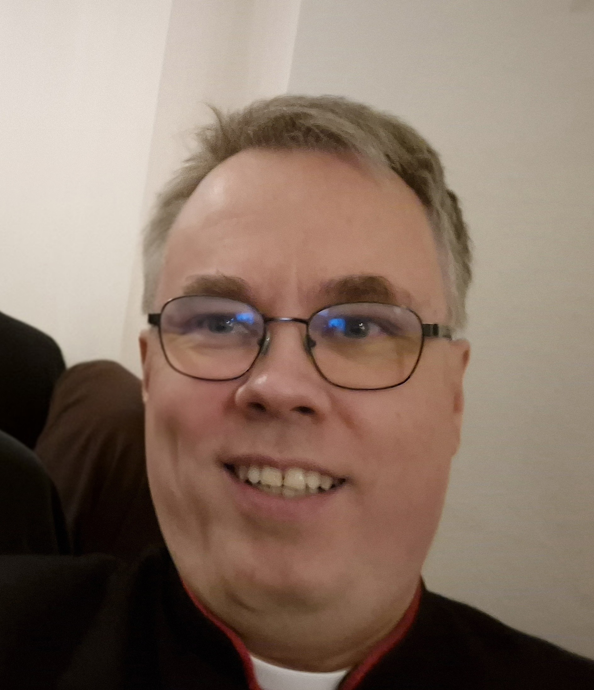
I am standing again for the General Synod.
The Church of England is a Church which is part of the One Holy Catholic and Apostolic Church, and lives in the communities and chaplaincies it serves, yet able to speak with a voice that reaches far beyond its walls.
I have served on The General Synod since 2015, with a period away before returning. I want to offer that experience again at a time when the Church needs both courage and good governance.

WHY I AM STANDING
I believe the Church is strongest when it is ordered and synodically governed: when bishops, clergy and laity share responsibility, decisions are made transparently, and Synod takes seriously the vocation entrusted to it.
I believe God has called every human being. God’s love is not rationed according to who we are, where we come from, whom we love, our abilities or our circumstances. The Church should be a place where every person can know that they are welcomed as someone made in the image of God.
That is why I am standing as part of the inclusive candidates’ group. Inclusion is not an optional extra to the Church’s mission; it follows from our understanding of God and of the Body of Christ. To support this view, I am supporting the work of Together for the Church of England.

WHAT I BRING
I bring long experience of the governance of the Church of England, including General Synod and the structures of the Diocese in Europe. I understand both the formal machinery of the Church and the human reality behind it.
I bring experience of strategic thinking and community building. Good governance is not simply about procedures: it is about seeing where the Church needs to go, bringing people with us, and building relationships strong enough to sustain difficult work.
I am a Finn from Lapland, and have served the Church in Finland and now Denmark. Living and ministering across national and cultural boundaries has taught me to see both the particularity of local communities and the wider Catholic vocation of the Church. I am a “continental voice” from Northern Europe.

CLERGY WHO CAN FLOURISH
As a clergy candidate, the wellbeing and flourishing of clergy are particularly close to my heart. The Church asks much of its ministers; we should also make sure that clergy have the conditions in which they can flourish in their vocation and mission. That means taking seriously wellbeing, sustainable patterns of ministry, fair and clear conditions of service, proper support and the ability to exercise ministry without unnecessary burdens. Caring well for clergy is not separate from mission: clergy who are able to flourish are better equipped to serve the people and communities entrusted to them.
The General Synod has a central role in setting the Church’s strategy and direction on safeguarding. Both the national and diocesan safeguarding teams and bodies need not only support but also a clear direction of travel so that, while necessary improvements and changes are taking place, the work continues to keep the Church a safe place for all.

WHAT I HOPE TO OFFER THE NEXT SYNOD

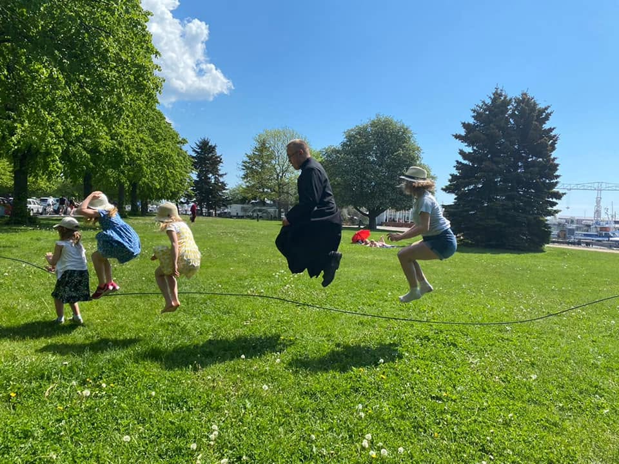
A SYNOD THAT SERVES THE CHURCH
I want to help General Synod remain a place where the Church of England listens, discerns and decides together. Synodical government matters because the Church is not simply an institution administered from the centre.
It is a communion of people, parishes, chaplaincies, dioceses and communities, called to witness to Christ.
Good governance should strengthen mission rather than become an end in itself. We need strategic thinking, sound stewardship, clear accountability and the courage to make decisions — while remembering that behind every policy are real people and real communities.

INCLUSION WITH A MODERN CATHOLIC VISION
I want to be an inclusive voice without losing sight of the breadth of the Church. I believe we can hold together a strong commitment to equality with a serious commitment to the Catholic and Apostolic nature of the Church.
I want a Church in which disagreement does not make us enemies; in which those who have historically felt excluded can flourish; and in which our common life is shaped by the conviction that every human being is called by God and bears God’s image.
I will continue to support Together for the Church of England and the wider inclusive movement. I also want to build bridges: listening carefully to those with whom I disagree, seeking common ground where it exists, and speaking clearly when justice and inclusion require it.

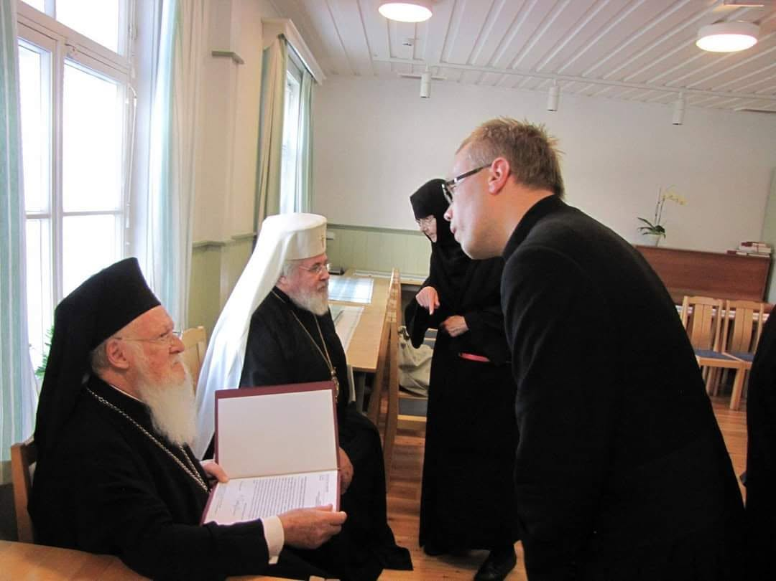
ECUMENISM AND THE WIDER CHURCH
My ecumenical experience has convinced me that the Church of England is most faithful to its vocation when it understands itself as part of something larger than itself. Our Anglican identity is not isolationist. We are part of the One, Holy, Catholic and Apostolic Church, and our relationships with other churches are part of our witness.
Having served across Lutheran and Anglican contexts and across Europe, I can bring to Synod a practical understanding of ecumenism: friendship, shared mission, theological conversation and the patient work of building trust across boundaries. I have worked closely with free churches as well as the Roman Catholic Church and Orthodox Churches.
I was brought up in the Finnish Lutheran Church but ordained in the Church of England and have served all my time in ministry in the Diocese in Europe.

WHY ME?
I am offering experience, a European perspective, strategic thinking, ecumenical understanding and a commitment to an inclusive Church. I want to help the Church of England become a stronger, more confident and more outward-looking Church: faithful to Christ, serious about its governance, generous in its welcome and ready to serve the communities God has entrusted to it.

I would be delighted to have your first or high-preference vote.
The Revd Canon Tuomas Mäkipää · Chaplain of St Alban’s Church, Copenhagen
chaplain@st-albans.dk

