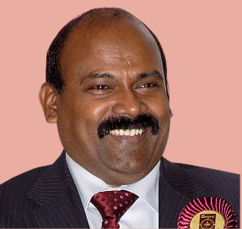

Thamarai Pandian
Lay representative, Christ Church, Kyiv
Lay Chair, Eastern Archdeaconry

Dear Brothers & Sisters in Christ,
I Praise, Our Lord & Saviour Jesus Christ to give me an opportunity to Serve in the Diocese “House of Laity”, GS 2026.
My Church activities
One of the founders of Christ Church, Kyiv, along with Rev. Johnathan Frais to plant Church in Kyiv. I am, passionate about Church building, financial self - sufficiency & growing the congregation among the expats as I had donned various roles, Church Warden, Treasurer, many terms elected as the EAD, Representative. We hosted the EAD Synod in Kyiv 2018.
Why I am Standing
My calling is to be a PEACE Maker as we experience the challenge of living in a War torn area with uncertainties & challenges to worship every Sunday. The C o E, is in a special position to offer a Christian Peace presence in every International community, and in Europe we bring the Good News of Jesus to varied denominations, cultures, War conflict areas & Orthodox Churches.
My pledges to you, Accountable, Engaging & Prayerful.

Yours in Christ.
Thamarai Pandian

