A Year in the Life of St XXX, Anytown  Sharing God’s love with our community |  | Insert your Church logo
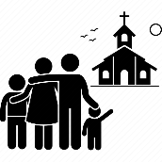 | 80 adults & 7 children  our worshipping family
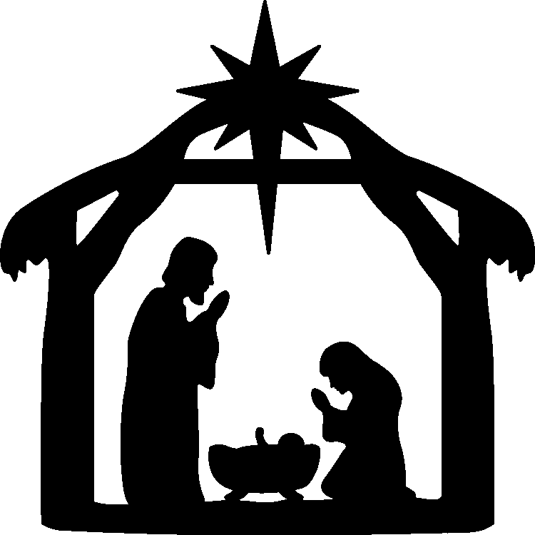 | 250 worshippers  joining us for Christmas services
5 baptisms, 4 weddings & 7 funerals
sharing key life events with our community

100 church services
in-person and on Zoom

 | 150 Facebook followers
 | £2,000 donations to the Ukrainian appeal
 | 28 church & community groups using our building
 | 30 community events including Coronation celebrations, Christmas fayre and lunches
THANK YOU…
…for all that you have contributed to the life of our church.
Give thanks to the LORD, for he is good; his love endures forever.”
1 Chronicles 16:34

