A Year in the Life of St XXX, Anytown  Sharing God’s love with our community |  | CHURCH LOGO
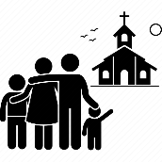 | 80 adults & 7 children  our worshipping family
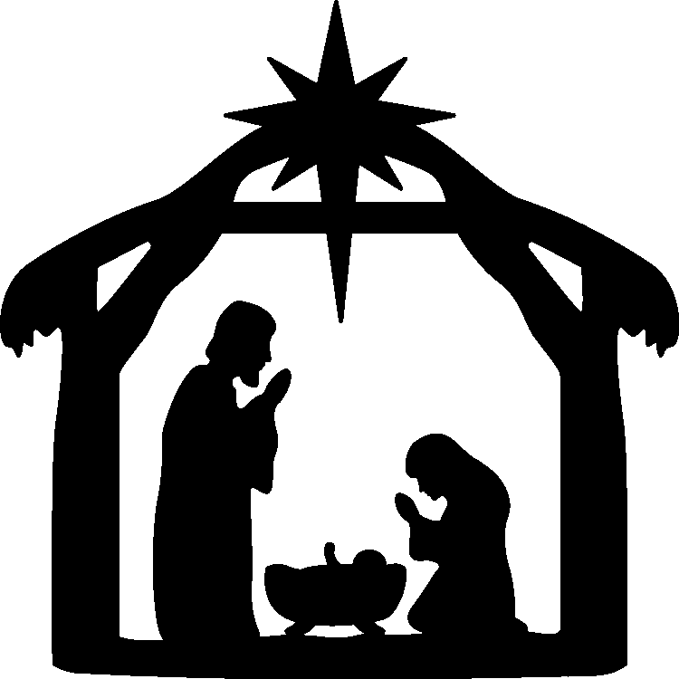 | 250 worshippers  joining us for Christmas services
5 baptisms, 4 weddings & 7 funerals
sharing key life events with our community

100 church services
in-person and on Zoom

 | 150 Facebook followers
 | £2,000 donations to the Ukrainian appeal
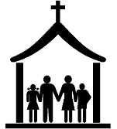 | 28 church & community groups using our building
 | 30 community events including Coronation celebrations, Christmas fayre and lunches
THANK YOU to everyone for your support.  If you would like to make a donation to our work, please scan our QR code with your mobile phone or make a cash donation. |  | QR CODE LINKED TO YOUR ONLINE GIVING PAGE

