The environmental impact of our travel
Calculating the carbon footprint of our journeys

Introduction
As a follow-on to the introductory document on travel reporting issued in October 2023 [ 231018 Chaplaincy travel footprint guidance rev2 (anglican.org) ], this document explains:
1. how to prepare your travel data for the first quarter of 2024 ready for input into 360Carbon, 2. how to create a 360Carbon account, 3. how to input the data into 360Carbon and calculate its carbon footprint, and 4. how to provide that data to the Diocesan team for inclusion in the Net Zero Carbon progress report for the June 2024 Diocesan Synod.
Reminder: This quantification is for monitoring purposes only, it is not a control exercise or to make comparisons between chaplaincies. We recognise that travel is necessary to accomplish our mission, and in some places the only viable means of making some journeys is by car or plane. Understanding where our emissions come from is the first step to considering how we might reduce them (which does not necessarily imply less travel).

- Preparing your travel data for input to 360Carbon
Thank you for recording your chaplaincy’s “business” travel for January-March 2024.
As a reminder, the travel concerned in this exercise is all work-related travel undertaken by chaplains and other paid staff, plus any travel costs reimbursed to others, such as travel to Archdeaconry Synods or pastoral visiting. All methods of travel which generate carbon emissions are concerned – planes, trains and automobiles, ferries, all types of public transport. Mileage in electric cars is included. Further explanations are in the initial guidance document (link in introduction above).
Some transformation of your data is required before input into 360Carbon, because the programme uses average monthly travel data to calculate annual carbon footprints, and as it is UK based it works with miles not kilometers. We have prepared a small spreadsheet to do these transformations and to generate the numbers you need to input to 360Carbon. The spreadsheet (File “240416 Preparing data for 360Carbon”) is circulated together with this document.

Instructions for using the file:
Open the file and make sure that you are in Worksheet 1, labelled “Input Q1 2024” by choosing the “Input Q1 2024” tab at the bottom of the screen.
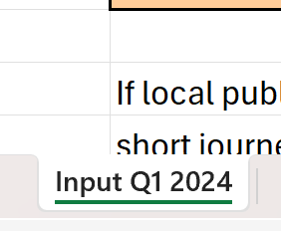

The worksheet has been protected so that you can only change the cells where you need to input data. These are coloured light orange.
There is a box for each of the travel types that contribute to our carbon footprint, except air travel. Flights will be entered directly into 360Carbon using the airport codes and do not require any prior calculation of distance.
Data should be inserted as the total km driven/travelled for each category of vehicle/travel that your chaplaincy/entity has used during the 3 month period January-March 2024. For example, for small cars:
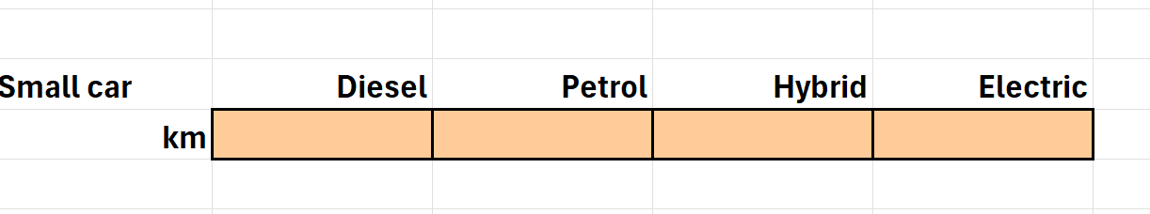
If you need help to calculate distances travelled by train, you could use Google Maps (put in the start and end stations of the journey, choose the public transport option, click on the start station and move along the route clicking as necessary at corners/bends. The total distance will be shown in the dialogue box) or use the EcoTree calculator Taking the train? Why EcoTree suggests contributing to the environment. which will calculate distances based on the start and end stations of each journey (it will also provide an emissions calculation, but at this point you need the distance, not the emissions data).
If you know the distances travelled for local public transport (bus, tram etc) then please do include them. If you do not have this data, for example people use travel cards based on number of journeys or time travelled rather than distance covered, don’t worry. If it is possible to estimate the distance travelled (e.g. because there are frequent journeys between fixed points such as chaplaincy office, other churches, hospital etc) so much the better, but if this is not possible, please leave these boxes blank. Short distances on public transport account for a very small proportion of our travel emissions and omitting them will not significantly alter the final figures.
When you have put in the data for all the types of transport used (except for flights as noted above), click on the “Output Q1 2024” tab at the bottom of the screen.
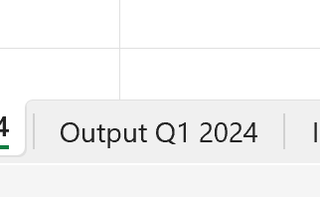
This will move you to the worksheet with the results of the conversion calculations. The green boxes show the numbers that you will need to input to 360Carbon. (Your original data has been converted from kilometers to miles, and divided by 3 to give a monthly average, because 360Carbon requires a monthly figure as input). Apologies in advance to any data nerds reading this (I am one myself!) – please grit your teeth and overlook the impact of rounding the output data. Again, in the overall picture this will have no significant effect. The small car example again:
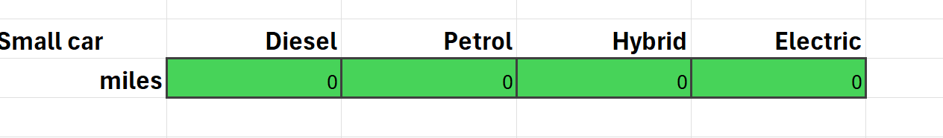

- Creating a 360carbon account for your chaplaincy/entity
You will use the application 360Carbon each year to calculate the carbon footprint of travel and relevant buildings.
If you have not yet created an account, here’s how to get started.
1. Click here: https://360carbon.org/en-gb/
2. Fill in your name and email address and presto, you are in.
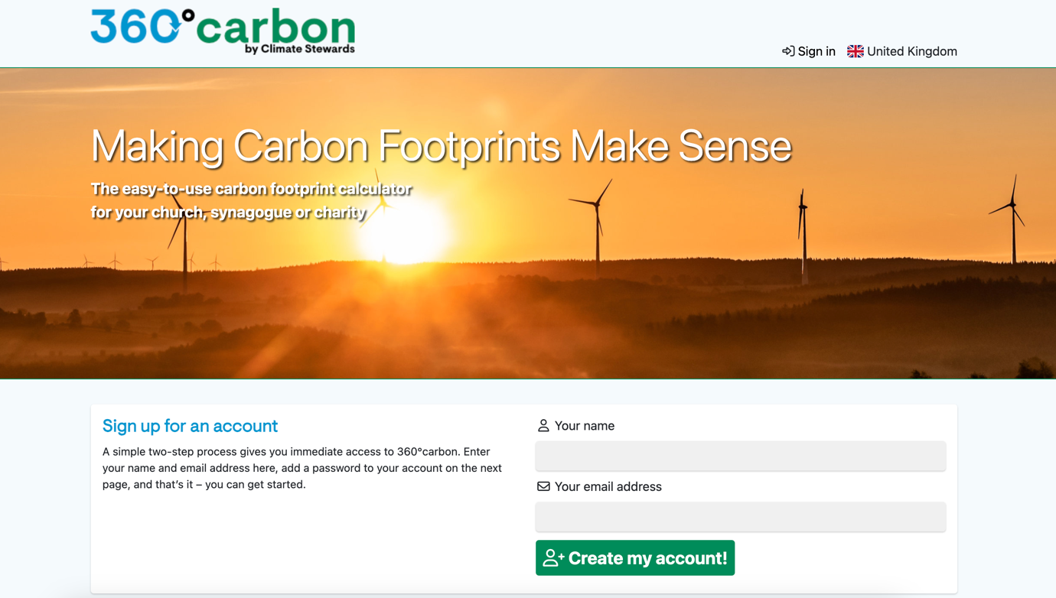

3. Fill in the organisation box with the name of your chaplaincy
4.Then, you will see you have the option of inviting other members to join your group.
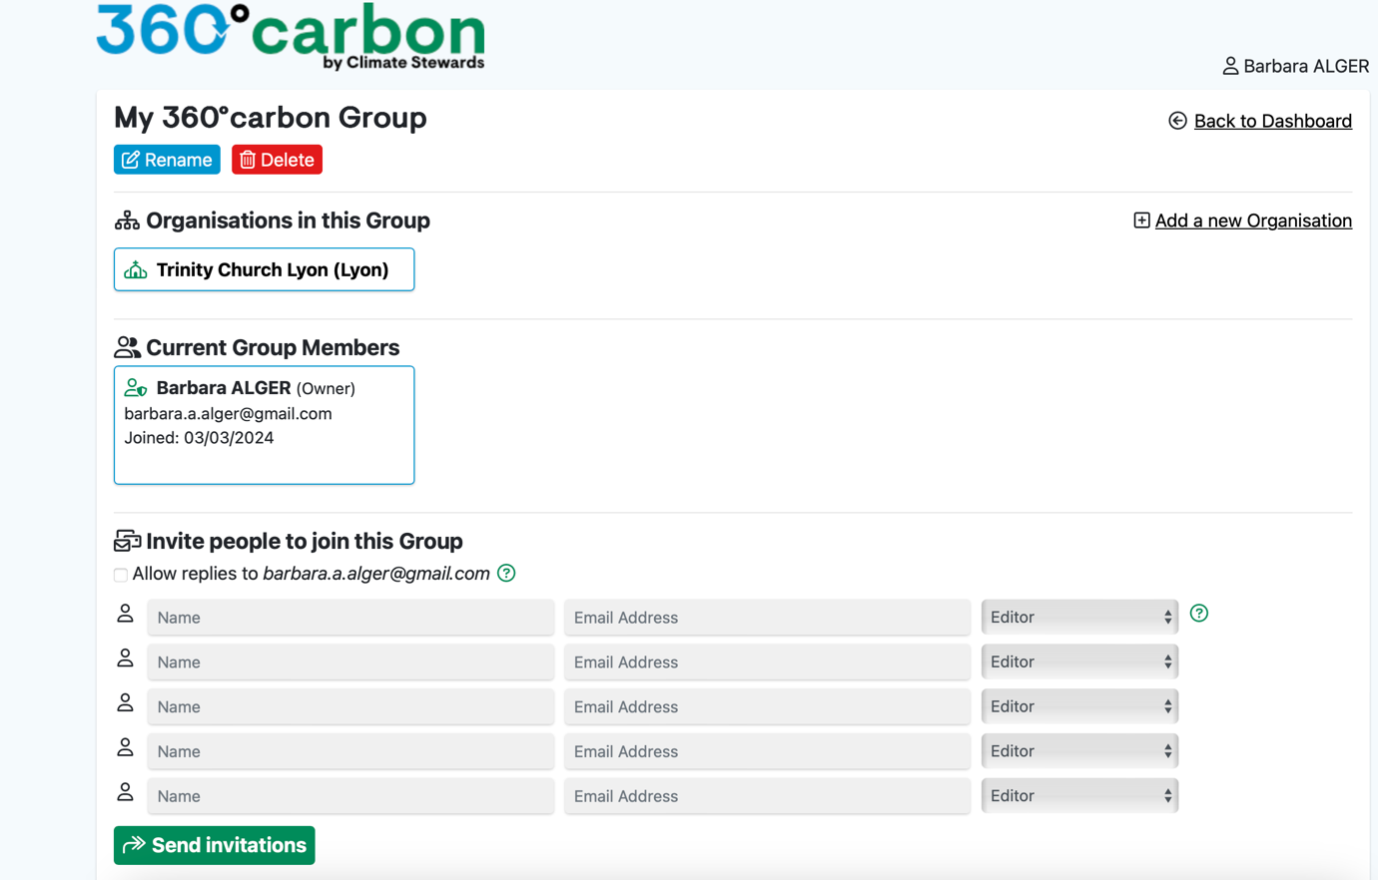

- At first, try exploring the 360°Carbon application on your own (Read Section 3 below first!).
- Well done!

- Inputting data into 360Carbon and calculating the carbon footprint
First of all, please do not be intimidated by the broad scope of 360Carbon. It is a comprehensive tool which has many different sections and functionalities. We are only going to use the staff travel sections, which only require the limited data that you have prepared.
When you log into your 360Carbon account, you will be invited to create a carbon footprint file. We suggest that you call this “Name of Chaplaincy 1st Quarter Travel 2024”. As time goes by you will be building up a library of carbon footprints year by year. Opening this will take you to a screen titled “About Your Church”. You do not need to complete any of these fields!
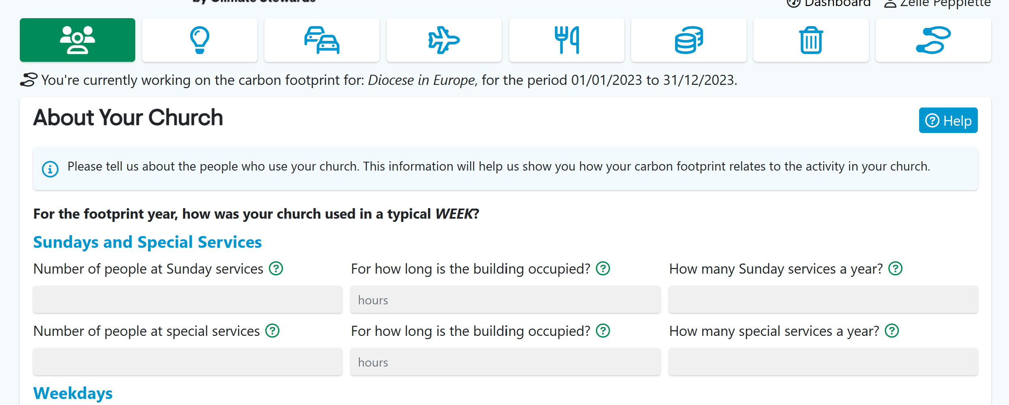
Instead, click on the third icon in the menu bar (2 cars), which takes you to the travel screen.
Half way down the screen you will see two boxes, “congregation” highlighted in green, and “staff” to the right. Click on the “staff” box (we are not recording congregational travel). The “staff” box will now be highlighted in green.
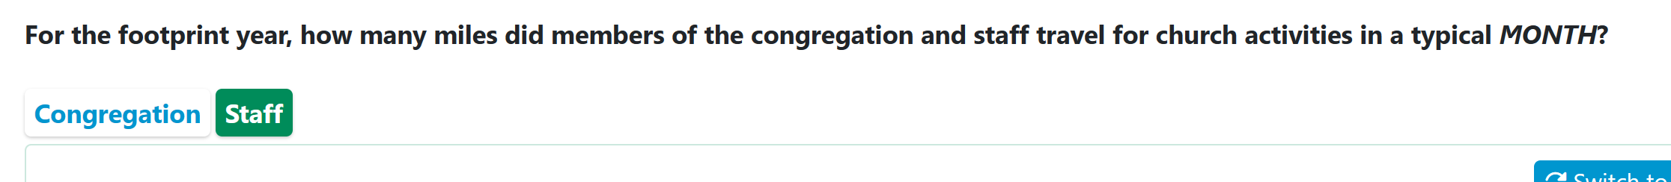

To the right of the screen, you will see a blue box labelled “Swotch to Advanced”. Click on this.
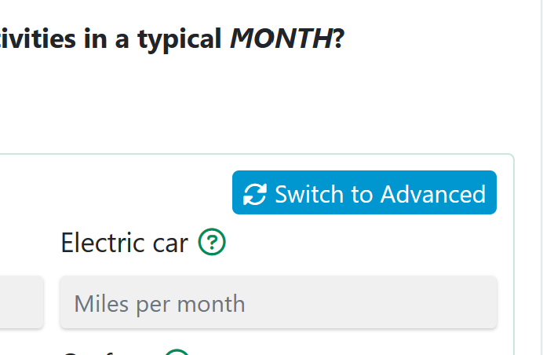
You will now see a screen with a layout almost identical to the “Output Q1 2024” screen from your data spreadsheet.
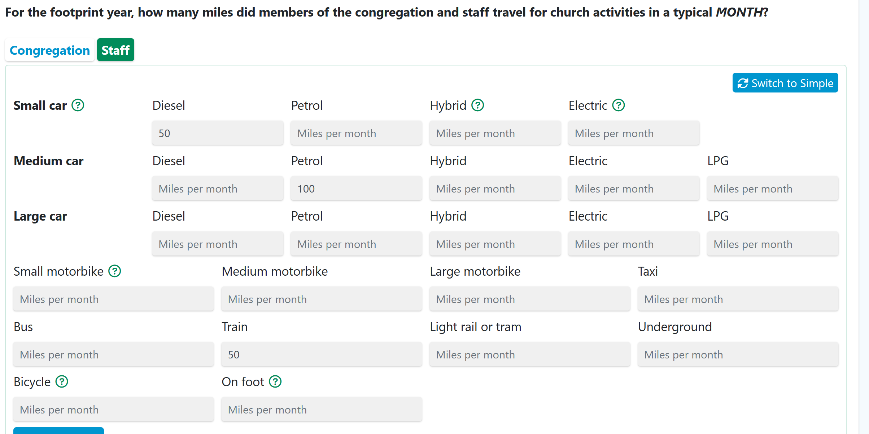
Please add the data from the green boxes in your “Output Q1 2024” screen into the corresponding boxes in the 360Carbon Travel screen.
You will see that the 360Carbon Travel screen also has boxes for travel by bicycle and on foot. These do not contribute to carbon emissions, but are useful to highlight the amount of non-emitting travel. We have not asked you to record travel on foot/by bike as we are concentrating on measuring the carbon footprint of our activities, but you may find it interesting to include this for your own purposes (e.g. measuring a shift over time).
Once all your travel data is entered, press the “Calculate” button and a figure for your annual staff travel emissions will appear. Click on the green “Save” button.
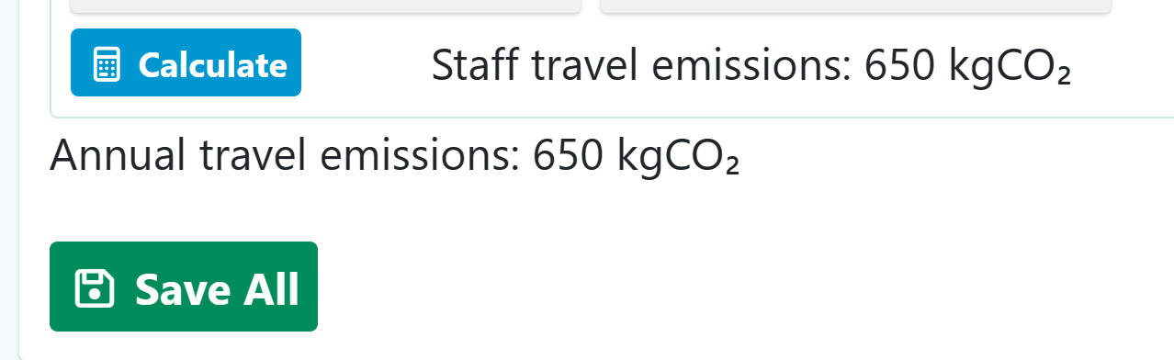

You are almost done!
If any flights were taken on church business during January-March 2024 (principally relevant for Bishops, Archdeacons, Diocesan Staff and chaplaincies whose representatives flew to the Gibraltar Archdeaconry Synod), please move to the flights page by clicking on the airplane icon.
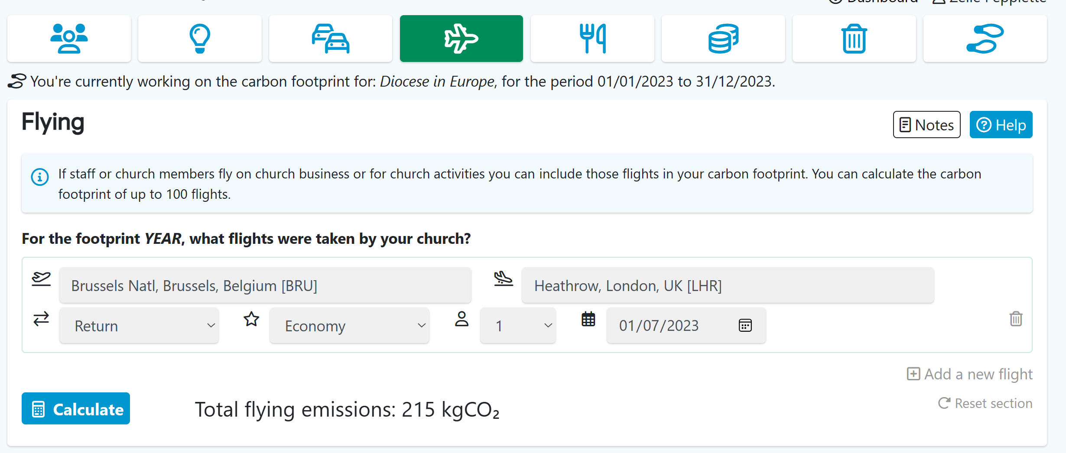
Recording flights is simple – you have to type the name of the start and end of each leg of the journey and pick the corresponding airport from the list that appears. For each flight you are asked to choose between Return and Single, Economy/Economy+/ Business/First, add the number of passengers and the date.
Once all your travel data is entered, press the “Calculate” button and a figure for your annual staff travel emissions will appear. Click the green “Save” button
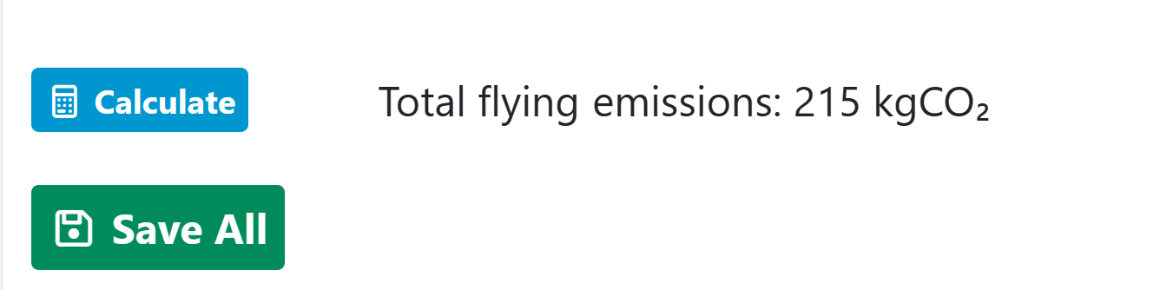
In the icons menu, move to the footprint icon (far right).
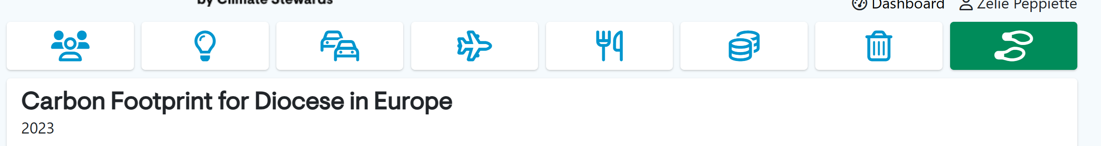
Under this you can see the emissions for your chaplaincy. Scrolling down (underneath the heading “Emissions by Scope” you will see “Download your footprint”.
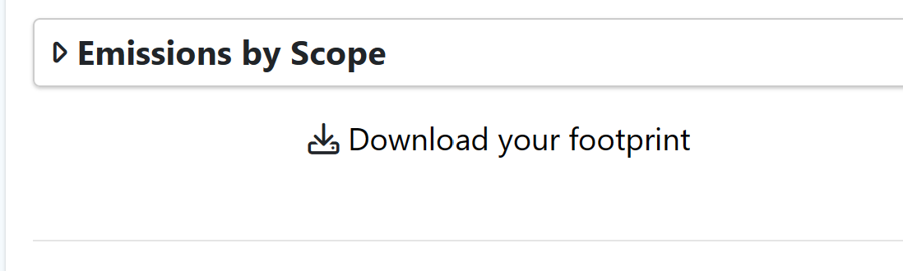
Click on this, and a pdf file will open which shows the emissions for each category of transport. Please save this file, including your chaplaincy name in the filename. Note that 360Carbon has extrapolated your data to provide an estimated figure for the whole year. To obtain data for the first quarter only, you need to divide the “travel” figures by 4 (not any flights, they count as they are).

- How to provide the data to the Diocesan team
The data from each chaplaincy and from the Diocesan staff and clergy will be compiled and included in the annual report on progress towards Net Zero that will be presented to the Diocesan Synod.
Please send the pdf report produced by 360Carbon by email to Barbara Alger, the Diocesan Net Zero Officer (Barbara.Alger@european-anglican.org) and to Zélie Peppiette, Caring for Creation Working Group (zelie@peppiette.com) by 9th May 2024.

Many thanks for your help!

Note
In future years, chaplaincies will be requested to report travel emissions for the previous calendar year by end-March the following year. i.e. data for 2024 will be requested by end-March 2025. This allows for data to be collated and included in the annual progress report to Diocesan Synod.
This request for quarterly data is exceptional, in order to have some quantified information available for the June 2024 Diocesan Synod.
Ultimately, it is anticipated that the Diocese will be able to access data directly from 360Carbon. This will avoid the need for chaplaincies to send in their emissions reports.

Zélie Peppiette for the Caring for Creation Working Group, April 2024

