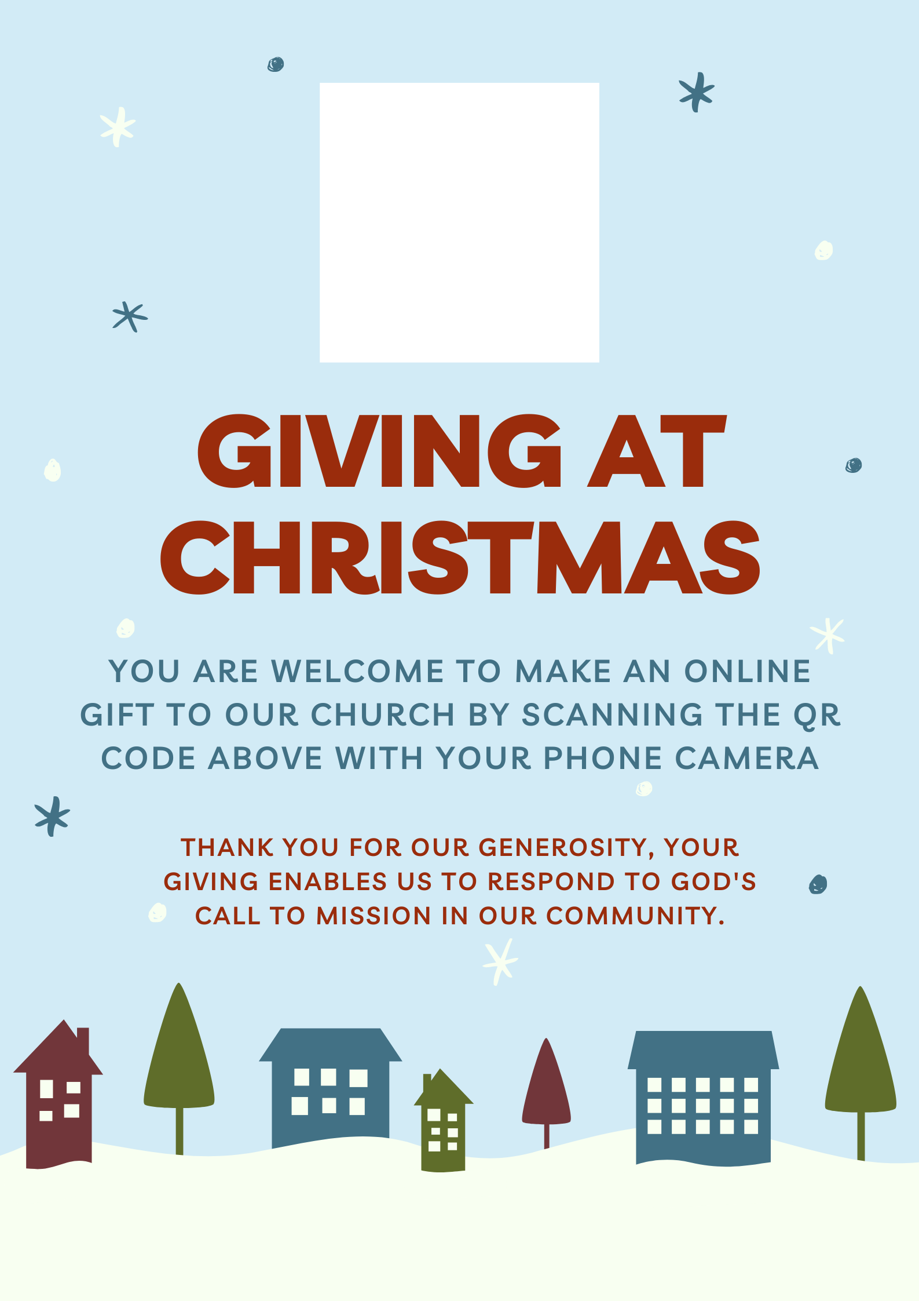

**Chaplaincy name or logo**

**IN THE DIOCESE IN EUROPE ‘MESSAGE’ BOX PLEASE INSERT THE NAME OF OUR CHURCH**